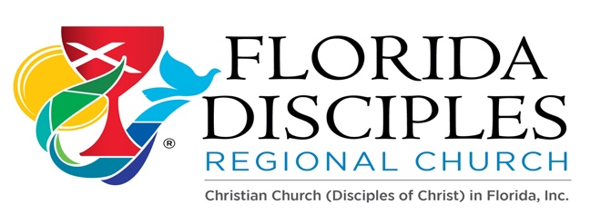

Cómo Hacer: para los nuevos plantadores de iglesias y ministerios:

Políticas / Procedimientos:
- Por favor lea las Pautas de la Comisión de Congregaciones Nuevas y Afiliadas https://www.fldisciples.org/new-and-affiliating-congregations.html

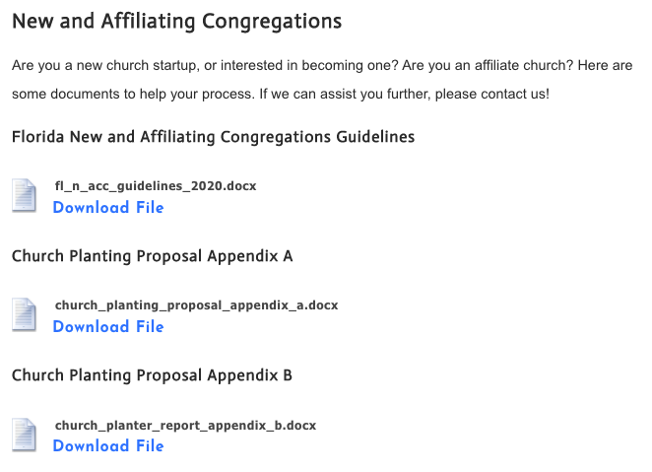

- Solicitar la propuesta de plantación de iglesias de becas regionales
- Mientras recibe fondos de la Región de FL, por favor entregue cada año el
Informe Anual del Plantador de Iglesias y solicitud de financiamiento al Consejo de Liderazgo
- Asistir a la reunión mensual de apoyo de los Nuevos Ministerios de la Región de Fl (2do martes de cada mes por zoom)

Sunbiz / Incorporación sin fines de lucro:
- Crear una junta básica (Presidente, Vicepresidente y Secretario, etc.) y tener el nombre y la tarjeta de crédito para pagar la tarifa.
- Encuentre y registre su nombre ficticio.
https://www.dos.myflorida.com/sunbiz/start-business/efile/fl-fictitious-name-registration/
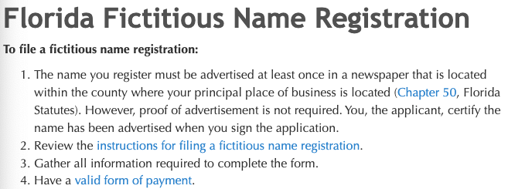

EIN: As part of the Incorporation process the church needs an Employer Identification Number (EIN) provided by the IRS. Please go and apply for the EIN Online with the IRS at:
https://www.irs.gov/businesses/small-businesses-self-employed/apply-for-an-employer-identification-number-ein-online

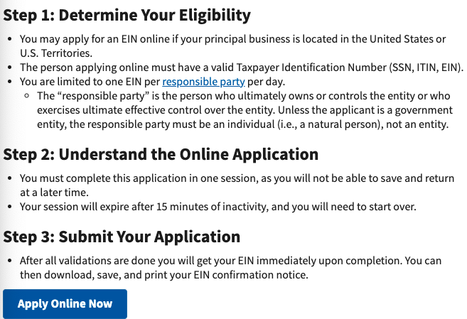

Start the church by creating a Non-Profit Corporation using:
https://www.dos.myflorida.com/sunbiz/start-business/

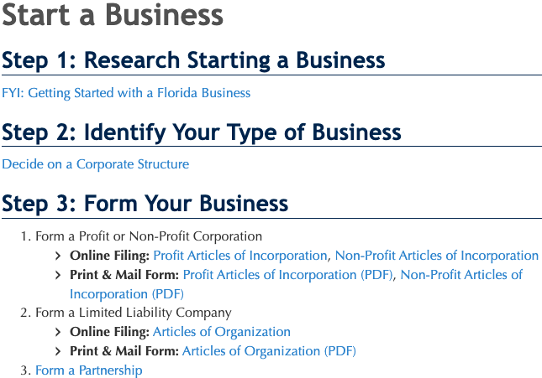

Every year file the Annual Report and pay the fee to update the corporation: https://services.sunbiz.org/Filings/AnnualReport/FilingStart

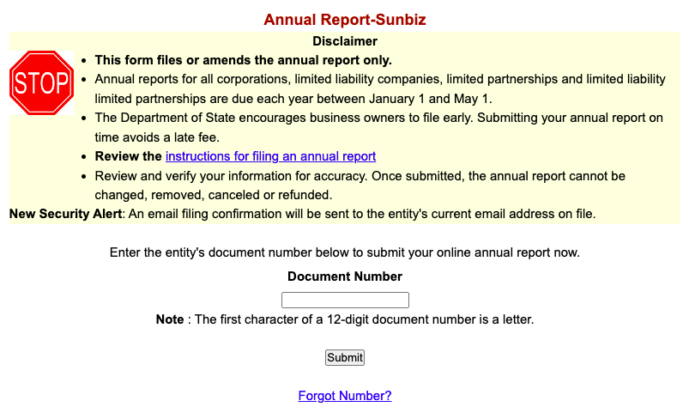

Letter of 501c3: Once the FL Regional Leadership Council has accepted your new ministry as a congregation in formation or ministry, request a letter of 501c3 from the Regional Ministry.

Open a bank account: With all the prior documents you will be able to open a bank account under the name of the new church/ministry. Ask the bank for requirements, they may require a letter with the EIN, incorporation docs, 501c3 letter from FL Disciples Regional Church, etc.

State Tax Exempt Certificate: Apply for a FL state tax-exempt certificate. https://floridarevenue.com/taxes/businesses/Pages/sales_cex.aspx

Expectations:
- Attend the Leadership Academies from the General Church New Church Ministries with the team of your church: (Usually in September each year) https://newchurchministry.org/
https://newchurchministry.org/services/leadership-academy/
  - Start Track ($500 – Region/Transportation on their own)
  - Sustain Track ($500 – Region and Congregation will pay half)
  - Multiply ($700 – Region and Congregation will pay half)
- Leadership Council Representative: Attend to Leadership Council Quarterly to know what is happening in the Region or assign a church leader the responsibility to attend.
- Attend the FL Region New Ministries monthly Zoom support meeting (2nd Tuesday of each month).
- E-Glimpse: Read the E-Glimpse every other week to be informed of the Regional events and other groups' activities and/or training. Encourage participation among your church members.
- Giving form: Educate yourself and your congregation on how to give to the different disciples’ ministries and begin a faithful path of giving at the level you are able:
https://cdn.disciplesmissionfund.org/wp-content/uploads/2017/12/23191000/Remittance-Form-English-2017.pdf
- ALEX: Fill out the directory of the disciples as a congregation in formation: Go to…
https://alex.disciples.org/

Important Links for your use:
- Church Extension: Building Loans https://disciplescef.org/
- Pension Fund: https://pensionfund.org/
- Week of Compassion: https://www.weekofcompassion.org/
- National Benevolent Association of the CCDOC: Training for New Ministries
https://www.nbacares.org/

Other References:
https://disciples.org/
https://www.fldisciples.org/index.html
Letter of Call: Fill out a letter of call with your congregation which can be updated annually.
(Please see next page…)

